No to Plan Larios – Bulletin 3 Fri 8 May 2020
This is the third in a series of updates on the campaign to stop the Larios and Ayuntamiento de Nerja’s plans to build a golf course and luxury development in Maro. The views are personal and do not reflect the opinions of other individuals or groups unless where stated and permission has been given

Petitions

The websites and petitions linked to opposing the Larios plan continue to grow, both in number and scope. The main Spanish site Otra Maro y Nerja es Posible has clocked up more than 7,500 signatures and now has a Swedish language option in addition to French, German and English.

Of the two change.org petitions, Evitar la construcción de campo de golf en Maro is hitting around 17,000, whilst ‘Andaluces Levantaos’ (protesting the Junta’s tinkering with laws protecting Nature) has topped 37,000 hits. Please make sure you’ve signed, and that your friends have toe. Let’s keep the pressure up!

Mediawatch

The Plan Larios issue has attracted a lot of media coverage – in the press, on the radio, and even on TV! Regional daily, El Diario, in an article of Apr 23, states baldly that the convenio (agreement) is basically an arrangement in which the debts owed by the Ayuntamiento de Nerja to the Larios will be cleared if they reclassify protected land to allow development. National daily, El Pais, ran an article on Apr 25 quoting our local Plataforma who say that Maro is being sacrificed and the future of Nerja mortgaged. Centre-right El Mundo puts Nerja in its Andalucian context with a May 3 article ‘El litoral andaluz se calienta con nuevos proyectos urbanísticos’, citing 6 other development projects of a similar nature.

The mayor of Nerja, José Armijo, made this statement on101tv:
https://www.youtube.com/watch?v=I7Vyqb3N-CA&feature=youtu.be while the Plataforma’s Jorge Alaminos was able to put the opposing point of view at more length on 7tv: https://www.youtube.com/watch?v=8hewCbIv5IY

As with any media reporting, there are moments where potential bias, even prejudice, seeps through. Online journal ElCierreDigital quotes a respondent as saying the project has been conceived ‘Sólo para turistas británicos, holandeses y alemanes,’ whilst another report refers to the ‘hippies’ who have made their home on the land. With this amount of local and national coverage it can’t be long before the story hists the international press. Watch this space!

Political Process

To campaign effectively it’s important to understand something of the process by which the Larios plan may proceed. The issue has been made more complicated because of the COVID-19 pandemic, as well as the National Government’s move to block the Junta de Andalucia’s recent law changes on property development (known as the Decretazo.) The main steps, at least of the local process, seem to be the following:

The convenio (agreement) between the Larios’ estate agents, SALSL, and the Ayuntamiento de Nerja comprises two elements: the first recognises the Council’s debts to Larios; the second seeks a change to protected areas under the local development plan (the PGOU) permitting the development of Maro.

Since the convenio was published in Malaga’s provincial gazette on the 20 March of this year there would normally have followed a 20 day period in which anyone can put forward objections – or alegaciónes as they’re known in Spanish. With the COVID crisis interrupting things, the days will now be counted from the point when the State of Emergency ends.

There are then 2 months before the issue must be brought to the Pleno. This is a monthly televised meeting of the Ayuntamiento in which local law is debated and approved by majority Council decision. Members of the public can make their views felt at the end of the session during ‘Ruegos y Preguntas’ to which the Mayor, or his councillors, is obliged to respond. According to a private local source, the fact of being televised means that the Pleno offers an opportunity to ask awkward questions. After all, no politician likes to appear foolish on TV!

Jorge Alaminos of the Plataforma says it’s important to try and stop the convenio being approved at the beginning, although there will be further opportunities to put questions to the Pleno during the successive phases of modifying the PGOU. In the next bulletin, find out how to let the Council know what you think!
Other organisations

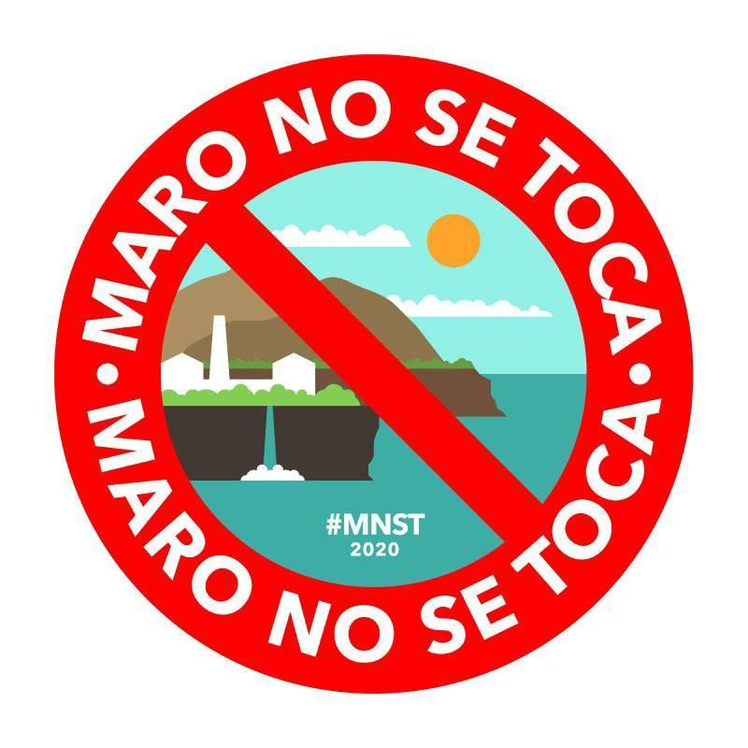
The Plataforma is not alone in wanting to campaign to save Maro. With over 13,000 members, new Facebook group Asamblea Maro no se Toca can fairly claim to be the fastest-growing social movement against the Larios Plans.

Founder Luis Al-Dada Castillón told me he didn’t know about the Plataforma when he recently founded the new group (originally called Tod@s para proteger Maro), but is willing to work with any other organisation with similar aims.

The group claims a young and international demographic and has organised itself into 14 working groups on themes like graphic/web design, liaison with Maro residents, economic/political activity etc., and decision making is done through the asamblea model of participative democracy.
For more info: https://www.facebook.com/groups/532595430783647/

In the Next Bulletin

Watch the Birdie A look into the issue of golf courses in Spain, in particular their impact on the environment. Notes from the Huerta - We take a trip to Maro and find out how local organic food production is booming. And of course our regular political coverage and media update.

And finally...

Thanks to contributors, Judy and Ana who have helped with this issue, and to all of you for your encouragement and support. In these difficult times having a focus for positive action feels really important. And whatever the outcome of the plan Larios, I see this as an opportunity to build community and start visioning the kind of future we want to see in this area.

Stay safe and have a good weekend!

‘Speak Truth to Power’
Quaker pamphlet 1955
Jon x

