‘El Puente’

Bridging Cultures to Protect Nature - Issue 5, July ‘20
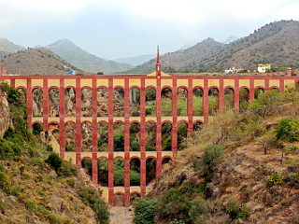

This is the fifth in a series of updates on the campaign to protect Maro and encourage community action towards a more sustainable culture. The views are personal and do not reflect the opinions of other individuals or groups unless where stated and permission has been given. Permission to use photos and graphics has been sought where possible. Quotes have sometimes been translated from other languages.

In the News…

Though the summer holiday season has seen a slowing down of media interest in Maro, there is still a steady trickle of reports covering various aspects of the Larios Plan.

Malaga Hoy (July 26) gave considerable space to the issue summarising events over recent years under the headline ‘Maro: Much more than a Golf Course.’ The piece, which quoted at length Jorge Alaminos of the Plataforma, drew attention – among other things - to the loss of agricultural potential of the region.

The Opinion de Malaga (18 July) reported on the PSOE’s move to have the Tribunal Constitucional (Spain’s Constitutional Court) stop the Junta de Andalucia’s legislation easing planning restrictions on protected land. The general secretary of Malaga’s PSOE, José Luis Ruiz Espejo, stressed that the Andalucian government should be “promoting a tourism linked to the natural heritage of our region” taking into account climate change and sustainable development.

A piece in El Diario (28 June) highlighted how the Larios plan could prejudice the Cueva de Nerja’s bid to be declared Patrimonio de la Humanidad. UNESCO’s criteria for inclusion contains a clause stating that the surrounding area has to be managed sustainably – something that a golf course and luxury housing/hotel development would clearly contravene.

Back in June, the Olive Press reported on the Ayuntamiento of Nerja’s plan to promote ‘nature tourism’ (though probably not naturism!) by putting in new hiking trails around Nerja and Maro and building a visitors’ centre at Cerro Gordo.

One juicy piece of news concerns a fight within the Larios family itself. El Pais (8 June) reported that personal differences between the four leading shareholders could jeopardise the development plan. Bárbara Gutiérrez-Maturana-Larios explained that it would be ‘impossible’ to commit to the project, not least because for some years she, her sister, and her mother have been seeking to wind up the the family business in which her brother, Carlos, has a major stake. She criticised SALSA (now SALSL), who manage the Larios estate, for prematurely publicising their golf-course plan back in April, saying not only does the company not have the 300 million euros necessary for the development, but also that the project doesn’t fit with the historical image and standard of quality the Larios family stands for. The matter is now being heard in the Constitutional Tribunal.

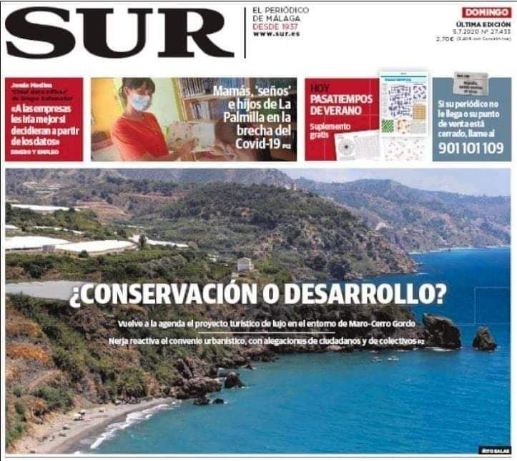

It was also good to see Maro and Nerja making the front page of SUR (Sunday 5th July), with the headline ‘Conservation or Development?’

The same article appeared in SUR in English (Jul 17-23).

The Political Process

With the phase for the submission of alegaciones now behind us, we must now wait for the Ayuntamiento’s decision on how they’re going to try and push through their agreement (convenio) with the Larios.

The COVID crisis has complicated matters as it’s not clear whether the council’s monthly meeting (pleno) in which the issue will be discussed will be of the ordinario or extraordinario type. The distinction is important because it determines whether or not members of the public are allowed to speak and make their objections ‘live’ (the event is televised and broadcast by Nerja TV). In the first case the meeting may be presencial, i.e. in person, whilst the second can legally be called with just 48 hours notice and will almost certainly be online and therefore exclude the public. A source close to El Puente has commented that if the meeting does turn out to be online, a demand should be made that a Plataforma representative be allowed to take part remotely.

Regarding who can speak, Jorge Alaminos of the Plataforma says that in the case of an ‘ordinary’ meeting, the campaign will elect its own represenative to speak in the Ruegos y Preguntas section, which concludes the business of the meeting, adding that this does not preclude other individuals speaking under their own name.

He adds that the Council’s team of civil servants is currently examining the public’s alegaciones from a legal and technical point of view (though they are not legally obliged to answer individual objections), and that the Council may have ultimately to modify the convenio in accordance with their findings.

In any case, the deciding factor will be the approval (or not) of the convenio by a majority of councillors. Out of the 21 councillors comprising the Council, the Alcalde (mayor) will have to secure at least 11 votes; for example, all of the PP’s 10 votes, plus 1 vote either from Ciudadanos or Vox. The opposition group of 9 councillors is formed by the PSOE (6 seats), Adelante Nerja Maro (2) and Unidos por Nerja (1), who are all against the convenio.

The Plataforma meanwhile are considering the possibility of calling an Asamblea or open meeting, but with the COVID numbers apparently rising again it seems more probable that some kind of small group meeting of representatives could be organised to maintain cohesion within the campaign as a whole.

New Visions

As the debate continues about the rights – or more accurately, the wrongs of the Larios plan, many concerned citizens are putting their imaginations to work on what could happen in and around Maro instead of a luxury development and golf course.

One group that has been working directly on compiling ideas for a sustainable future for the area is the loose collective of ecologists and tenant farmers meeting under the heading ‘Planes Alternativos Maro’. PAM have already produced a range of documents covering possible developments around the themes of agriculture, economy and education.

PAM representative, Jack Whitfield, who grows boniatos (sweet potatoes) in the area, says: ‘After this initial successful stage we now have to include the voices of the people of Maro in the process, collating and presenting the proposals.’ He acknowledges that this is no easy matter, but appeals to anyone interested in the process to get in touch with a view to forming a team dedicated to a community consultation (tel: 692 838 951).

Also amongst the PAM group is German architect and permaculturist, Vreeda Narture, who has lived and worked on the land in Maro for 4 years. She has brought together her professional knowledge and commitment to organic gardening in an innovative retrofit of the azucarera (sugar factory) and its grounds that she calls “Permaculture Factory’. According to Vreeda, the project would combine sustainable agriculture with social and cultural activities and be based on ‘modular systems’, such as shipping containers, which could be added to incrementally and which would showcase techniques of recycling, up-cycling and repairing, as well as ‘providing the local population with fresh organic food whilst protecting the existing unique flora and fauna of the area.’ (Further details on this plan from the editor, email below).

Two other interesting and related proposals are an ‘Incubator’ for new land-based projects and a Parque Agrario. In the first plan the sugar factory would be converted into an Agricultural University offering students the opportunity to experiment and develop mini ecoprojects and businesses without initial commercial pressure. The Parque Agrario model (such as Fuenlabrado in Madrid or that of the Guadhalhorce, Malaga) extends the concept through the surrounding landscape and links local land use with the wider community by offering employment opportunities, increasing food sovereignty and maintaining healthy, natural spaces for the wellbeing of all.

The search for a creative use of the buildings and space in Maro is not new. As long ago as 1984 Erik Tonsberg, a Swedish artist living in Nerja, presented a vision for the area to the then Alcalde. Later, Erik took the plan personally to the Larios family who, he recalls, “looked at it for some weeks and then handed it back.” Framed as a ‘Larios Museum’, the scheme emphasises the cultural richness of the area and comprises an arts centre showcasing painting, sculpture, photography and video work, with extensive development of the surrounding land into themed gardens, plus other attractions like a museum, café and cinema.

Perhaps what’s called for in Maro is a fusion of nature and culture; preserving the best of local agricultural practice and encouraging innovation, whilst adding value through local commerce, the promotion of a ‘circular economy’ (keeping money and other resources flowing within and around, rather than leaking out of, the local community), and culturally appropriate, sustainable tourist activity. We can only hope that with the stakes now being even higher and the future of the area in jeopardy, the authorities take more seriously the wealth of talent and creativity amongst the population of Maro and Nerja and take their proposals seriously. If not, we’ll just have to do it ourselves!

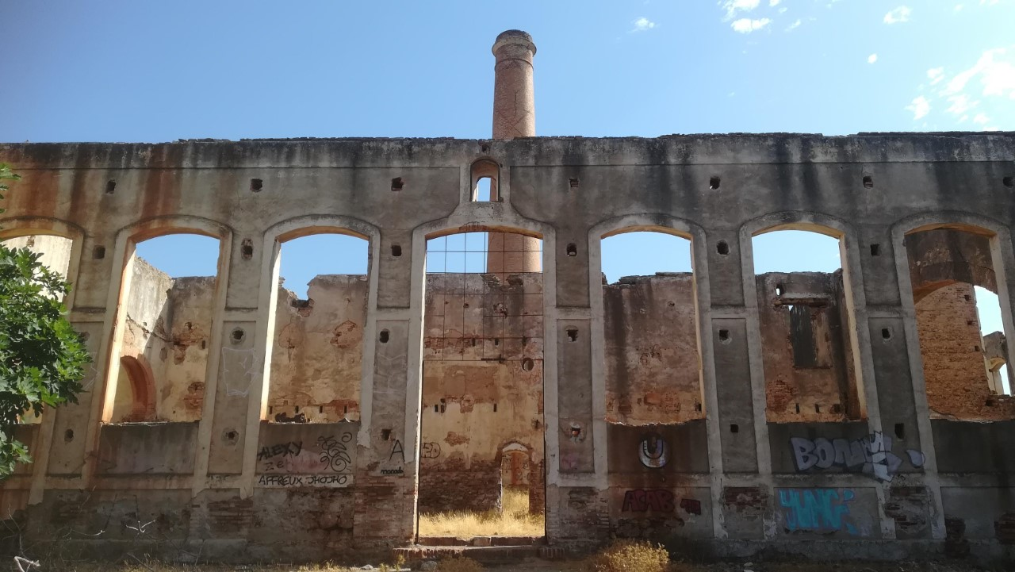

Sugar factory
facade

“You never change things by fighting the existing reality. To change something, build a new model that makes the existing model obsolete”.

Buckminster Fuller (American architect, thinker and futurist)

Editor: jonstein1@hotmail.com Proofreading/copy editing: Judy Rust

